Paper 2 Draft

1. Abstract
2. Introduction
3. Background
4. Methods
5. Results
6. Discussion
7. Conclusion
8. References

1. Abstract
2. Introduction

[USE LIT REVIEW]

Explain setting

Use Sayaka + Rohini papers

Since its onset in 2011, the Syrian conflict has produced a complex humanitarian disaster, with well over 5.6 million refugees and 6.6 million internally displaced persons,1 out of an estimated pre-war population of 23 million.2 During this period, Syria has suffered a number of health and healthcare challenges, including the reemergence of vaccine preventable diseases, such as polio and measles, targeted attacks on healthcare facilities, workers, patients, and supplies, and the disruption of public health surveillance in opposition-held territories. These challenges, coupled with massive inflation, limited supplies, energy shortages, lack of safe transportation, the loss of vital infrastructure such as water sanitation, and the flight of over half of Syria’s physicians have led to dramatic changes in the epidemiology of infectious diseases, non-communicable diseases, and mental health issues.

While a number of studies have sought to describe these events their immediate impacts, little is known about their cumulative impacts or how they have shaped Syria’s epidemiology over time

1. Background

Prior to the start of the conflict, Syria’s health system was comparable to other middle-income countries. The Syrian constitution stated that healthcare provision was the responsibility of the state and consisted of both government-run hospitals and primary care facilities as well as private facilities. The ministry of health serving as the main provider of primary healthcare. Advanced medical care was concentrated in the major cities, but the quality of healthcare infrastructure and equipment was often suboptimal, especially outside of major cities.3,4

Syria was undergoing an epidemiologic transition from communicable diseases to non-communicable diseases (NCD) in the two decades leading up to the conflict.3,5 Life expectance at birth was 75.9 years and child mortality at 15 per 1,000 live births, “on track to meet the Millennium Development Goal 4 target”.3,6 Syria had high child vaccination rates prior to the conflict,3,5,7 with outbreaks of major diseases such as measles, hepatitis A, and meningitis being well-controlled and poliomyelitis officially eradicated since 1999. Other non-vaccine preventable infectious diseases, such as leishmaniasis and scabies, were also well controlled.

Prior to the start of the conflict, the Syrian Ministry of Health (MOH) operated an infectious disease surveillance system which submitted yearly reports to the WHO regarding vaccination rates and number of reported cases of vaccine preventable diseases. Unfortunately, publicly available data from prior to the conflict are scarce and have limited reliability for a number of reasons, including lack of accountability, transparency, training, and underdeveloped health information systems.3,8

Indiscriminate targeting of healthcare facilities, transports, medical personnel, and patients throughout the conflict has had tremendous impact on Syria’s healthcare capacity, felt even more acutely outside of the cities. Since the start of the conflict, less than 50% of primary care facilities remained functional at the end of 2014,3 and over half of physicians left the country or were victims of the conflict.9 Coupled with the demands of a war, this has led to a restructuring of the limited healthcare capacity, with treatment of emergent cases given increasing priority over prevention and public health interventions, including vaccination.

The conflict has also disrupted the limited public health surveillance capacity of Syria, primarily in regions that fell outside of government control. This has contributed to diminished preventative services and uncoordinated or delayed response efforts, because outbreaks could not be detected early enough and there was not enough data to identify where intervention was needed most. This was highlighted in the Wild Polio Virus Type-1 (WPV-1) outbreak in 2013; detection was delayed for weeks and the response was slow, uncoordinated, and not properly targeted because of the lack of data regarding the geographic and chronologic distribution of cases.

This was the motivating cause for the two separate surveillance efforts that have since been established in territories under the control of the Syrian government and those outside of its reach by the Syrian MOH and the Assistance Coordination Unit (ACU), respectively. Both are modeled after and supported by the WHO’s Emergency Surveillance and Response System (EWARS). The surveillance system of the Syrian MOH goes by the same name, EWARS, while the one operated in other territories by the ACU goes by the Emergency Warning and Response Network (EWARN).

The data for this study comes exclusively from the EWARN in collaboration with the ACU. There are potential opportunities for future studies to use both systems in a jointly, although Ismail et al. have found systematic differences between these two sources of data that would need to be addressed.10

Although the ACU has collaborated and shared EWARN data with organizations and academics in the past, and also publish weekly and annual epidemiologic reports to the WHO, the Gaziantep Health Cluster, and in their newsletter, no organization or individuals have had access to the breadth of epidemiologic data that they have. Although the organization was started in 2013 and had an operational polio surveillance system by 2014, the ACU’s methods and coverage of multiple infectious disease syndromes did not fully developed until the start of 2015. Th EWARN has since continued on to the present day within their coverage areas, giving us valuable access to over 4 years of infectious disease syndrome data. In addition, no studies have analyzed the relationship between documented attacks on healthcare facilities and the incidence of infectious diseases in Syria throughout the conflict. Thus, this study hopes to contribute to our understanding of the impacts of the Syrian conflict and the relationships between health and conflict more broadly by using a uniquely robust dataset from the midst of conflict.

1. Methods

This was a retrospective review using an infectious disease surveillance data collected primarily in northern Syria between January 2015 and June 2019 by the Assistance Coordination Unit (ACU).

Setting

Governorate, district, subdistrict

Opposition vs government territory

Surveillance System

This research was done in collaboration with the Assistance Coordination Unit (ACU), “a national Syrian non-governmental, non-political, non-profit institution focused on maximizing the impact of assistance delivered to the Syrian people by coordinating the efforts of donors, implementing agencies, and community representatives.”11 The ACU provides information management, project coordination, capacity building, monitoring and evaluation, and advocacy for organizations and projects aimed at assisting the Syrian people in opposition-held territories.

Along with other project, the ACU maintains the Early Warning and Response Network (EWARN), established in 2014 and modeled after the World Health Organization’s (WHO) Early Warning and Response System (EWARS). EWARN is an active surveillance program, in which surveillance data is periodically requested from health providers, and was designed for rapid and cost-effective implementation in humanitarian or conflict settings to improve disease outbreak detection.12,13

EWARN covers 13 diseases and conditions, selected for their potential to cause epidemics, their association with high morbidity and mortality, and the potential for intervention in Syria.12 EWARN’s objective is the early detection of outbreaks and to communicate epidemiological data with partner organizations.

Note that cases are not laboratory confirmed, but rather meet the defined clinical and epidemiologic protocols discussed in the methods section. Thus, all following mentions of cases refer to clinically suspected cases. The ACU also conducts laboratory and epidemiologic investigations of outbreaks, but data collected from those activities will not be included in this study.

A study that compared the accuracy and consistency of reporting between EWARN, operated by the ACU, and EWARS, operated by the Syrian MOH, found that EWARS consistently underreported disease counts, and had lower rates of completeness and timeliness when compared to EWARN.10

|  |  |  |
| --- | --- | --- |
| Abbreviation | Clinical Syndrome | Suspected Disease |
| ABD | Acute Bloody Diarrhea | Shigellosis |
| AWD | Acute Watery Diarrhea | Cholera |
| OAD | Other Acute Diarrhea |  |
| AJS | Acute Jaundice Syndrome | Hepatitis A & E |
| ILI | Influenza-Like Illness | Influenza |
| SARI | Severe Acute Respiratory Illness | Avian Influenza A (H7N9), MERS-CoV, other |
| AFP | Acute Flaccid Paralysis | Poliomyelitis |
| MEA | Suspected Measles | Measles |
| MEN | Suspected Meningitis | Bacterial Meningitis |
| STF | Suspected Typhoid Fever | Typhoid |
| LEISH | Leishmaniasis | Cutaneous Leishmaniasis |
| UCE | Unusual Cluster of Health Events | N/A |
| UCD or UXD | Unusual Cluster of Deaths | N/A |

Case Definitions

Case classification

According to the WHO, “countries are advised to use the clinical classification scheme until their programmes meet the following two criteria: low levels of measles incidence or access to a proficient measles laboratory;” after achieving these tragets, the WHO recommends “a laboratory classification scheme should be used by countries in the low incidence or elimination phase.”15

|  |  |
| --- | --- |
| Syndrome | Case Classification |
| **MEA**:  Measles | Between 2015-2018, the ACU relied on the World Health Organization (WHO) definition of measles2. *Suspected cases* are those in which the patient presents with a fever and non-vesicular maculopapular rash, or in whom a healthcare worker suspects measles. *Clinically compatible cases* are those in which patients present with fever and maculopapular (non-vesicular) rash and at least one of cough, coryza or conjunctivitis. |
| **ABD**:  Acute Bloody Diarrhea | Acute bloody diarrhea is the clinical syndrome that aims to detect suspected cases of shigellosis. The ACU defines a suspected case as “acute diarrhea (three or more abnormally loose or fluid stools in the past 24 hours), with visible blood in stool (preferably observed by the clinician). Diagnosis is made by observing blood in a fresh stool specimen or asking the patient or mother of a child whether the stools are bloody.”1 |
| **AWD**:  Acute Water Diarrhea | Acute watery diarrhea is the clinical syndrome that aims to detect suspected cases of cholera. Suspected cases are defined as “any person aged 5 years or more with severe dehydration OR death from acute watery diarrhea in the past 24 hours), with or without vomiting.”1 Suspected cases are confirmed by bedside rapid diagnostic tests and, if positive, culture-conformed. Syria has not experienced any confirmed cases of cholera. |
| **OAD**:  Other Acute Diarrhea | Cases of other acute diarrhea are those in which the patient presents with “acute diarrhea (three or more loose stools in the past 24 hours), not due to bloody diarrheal or suspected cholera.”1 |
| **AJS**:  Acute Jaundice Syndrome | Acute jaundice syndrome is the clinical syndrome for suspected cases of acute Hepatitis A or E. It is defined as “acute onset of jaundice (yellowing of sclera of eyes or skin or dark urine), AND Severe illness (Fatigue, nausea, vomiting and abdominal pain) AND The absence of any known precipitating factors.”1  While AJS has many potential etiologies, such as yellow fever or leptospirosis, humanitarian and conflict settings are especially susceptible  to Hepatitis A and E outbreaks.16 An investigation is necessary to confirm the cause of an AJS outbreak, but results from ACU investigations will not be included in this study. |
| **ILI**:  Influenza-Like Illness | Influenza-like illness is a standard of infectious disease surveillance. It is defined as an acute respiratory illness with a measured fever >38°C, a cough, and onset of symptoms within the last seven days.1  The goal of ILI surveillance is to detect and monitor for possible influenza epidemics. Patients with additional symptoms of shortness of breath, difficulty breathing or chest pains, and has had possible exposure to H1N1 trigger and investigation for potential H1N1 outbreaks. H1N1 investigations are not included in this study. |
| **SARI**:  Severe Acute Respiratory Illness | Similar to ILI, severe acute respiratory illness is defined as an acute respiratory illness with a measured fever >38°C, a cough, onset of symptoms within the last seven days, and requires hospitalization, whether hospitalization is possible or not.1 Surveillance is aimed at detecting clusters or epidemics. |
| **MEN**:  Meningitis | Meningitis aims to detect cases of meningococcal meningitis. It is defined as any person with a sudden onset of fever of ≥ 38°C, and one of the following signs: nuchal rigidity, bulging fontanel in children less than one year old, altered consciousness, petechial or purpuric rash, or other meningeal signs that causes clinician to suspect meningitis such as photophobia, vomiting, delirium, coma, or symptoms of shock.1 |
| **STF**:  Suspected Typhoid Fever | Cases of clinically suspected typhoid fever are defined as: Any person with acute illness and fever of at least 38° C for three or more days with abdominal symptoms, including: diarrhea, constipation or abdominal tenderness progressing to prostration, and relative bradycardia.”  Additionally, symptomatic cases that have been in contact with a laboratory confirmed case of typhoid fever are included as suspected cases. |
| **LEISH**:  Cutaneous Leishmaniasis | Cases of suspected cutaneous leishmaniasis are those that have “skin lesions on the face, neck, arms, and legs (exposed body parts), which began as nodules and turned into skin ulcers, eventually healing but leaving a depressed scar.” Clinical history and appearance are sufficient for suspected cases, laboratory testing is used to confirm the diagnosis. This study reports on suspected cases, irrespective of whether diagnoses were confirmed, denied , or never tested. |
| **AFP**:  Acute Flaccid Paralysis | Acute flaccid paralysis is intended to detect suspected cases of poliomyelitis. Suspected cases are defined as “any child < 15 years with acute, flaccid paralysis or weakness, or any paralytic illness in a person of any age if poliomyelitis is suspected.”17 Polio is not the only cause of AFP; in fact, less than one percent of those infected with polio develop symptoms of AFP. However, it is the gold standard for polio surveillance.18 |

Data Collection

EWARN’s data management is hierarchically structured by geographic levels. Individual health facilities are at the “field level”, and data is actively collected from each center by Field Level Officers (FLOs). Each FLO is responsible for receiving weekly patient registers from the health facilities within their designated area. These registers are then submitted to District Level Officers (DLOs), who consolidate registers from each community and subdistrict within their designated district and then submit a weekly report to Central Level Officers (CLOs) at ACU’s headquarters in Gaziantep, Turkey. The CLOs then aggregate these reports and publish weekly case-counts at the district and governorate level.

The quality of the data is routinely assessed by calculating the completeness and timeliness of reporting for each district. EWARN enforces zero-reporting for the health facilities in its network to distinguish between non-reporting and true lack of cases, a crucial element for surveillance in a conflict setting where facilities or entire districts may be unable to report due to difficult circumstances.

Population estimates were obtained from the United Nations Office for the Coordination of Humanitarian Affairs (UNOCHA).14

Study Population

The study population consisted of every outpatient presenting at a healthcare facility within the EWARN coverage area that met the conditions for one of the 14 syndromic case definitions and consented to have their case reported to EWARN. Cases were deidentified and aggregated by sex (male, female), age (≤4 years old, > 4 years old), and subdistrict into weekly case-counts for each syndrome by the ACU prior to data-sharing.

Attacks on Healthcare Facilities

Several open source databases were identified to extract data on attacks on healthcare facilities. For the study, the data extracted included: (a) Start Date of Attack, (b) End Date of Attack, (c) Governorate Region of Attack, (d) Weaponry Used, (e) Perpetrator of Attack. Databases maintaining these statistics were identified through a broad, web-based search and were chosen based on the following inclusion criteria: (1) availability of data from the start of the civil war on March 2011, (2) monthly aggregated data, (3) a published and transparent methodology, and (4) a multi-tier verification procedure.

Data Management and Analysis

Data was documented and shared by the organization using Microsoft Excel. The results were analyzed and visualized using R. Descriptive analyses of surveillance data used characteristics of the study population, which included binary variables for age, sex, and geographic district. The χ2 test was used, with a P-value of <0.05 chosen as the threshold for significance.

Population

Population estimates for 2015 – 2019 were obtained from the ACU but originally were collected and distributed by the United Nations Office for the Coordination of Humanitarian Affairs (UNOCHA). These population estimates are conducted annually and distributed to UN agencies and other governmental and non-governmental organizations (NGOs) working on health-related concerns in Syria.

2015-2016 estimates were conducted at the district-level, while 2017-2019 were conducted at the subdistrict-level, limiting our population-dependent statistics to the district-level despite subdistrict-level granularity of the surveillance data. Population characteristics, including age and sex, are not a part of the population data, limiting our ability to estimate attack rates for subsets of the population.

Poisson

Data

**Laboratory criteria for diagnosis:**

* Presence of measles-specific IgM antibodies.

**Laboratory classification**

* + ***Laboratory-confirmed***: A case that meets the clinical case definition and is laboratory-confirmed.
  + ***Epidemiologically-confirmed:*** A case that meets the clinical case definition and is linked epidemiologically to a laboratory-confirmed case

Data and Sample Collection (*Part of data flow)*

Ethical Approval

This study was exempted by the UC Berkeley IRB. Data shared by the ACU included population-level data limited to the subdistrict level to avoid case tracing.

Results

Population

Population was estimated annually by UNOCHA, while our surveillance data was collected on a weekly basis, leading to distortions in incidence. Changes in population appeared as discrete jumps at the beginning of each year. This was addressed by linearly imputing weekly population estimates to minimize artifacts in estimates of incidence.

Surveillance System

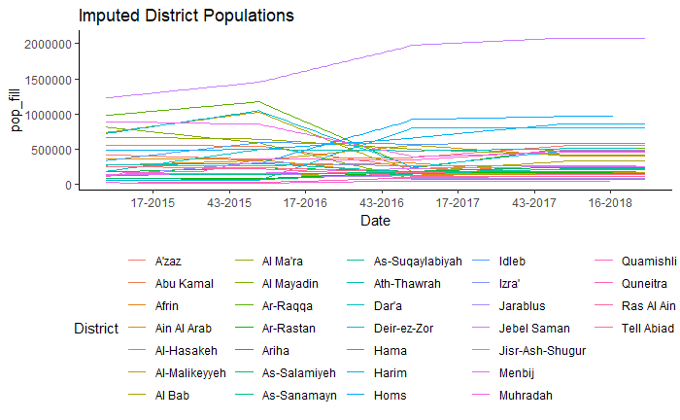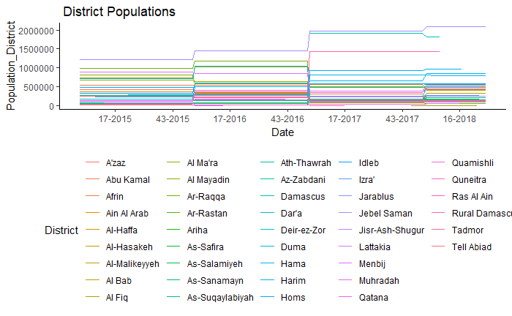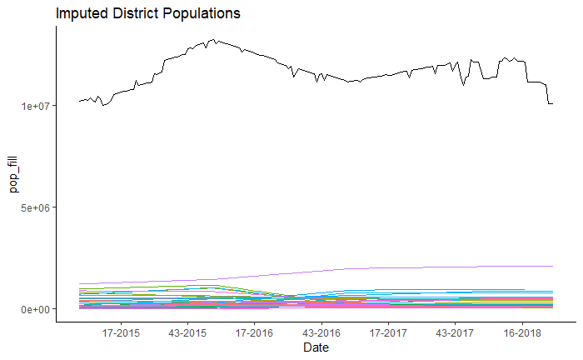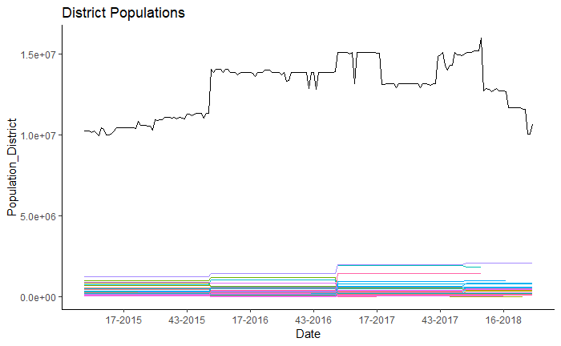

Data was collected from January 1st, 2015 to July 31st, 2019 through active surveillance of healthcare facilities within EWARN. Population-level information was collected, including 1) locale of each case at the subdistrict-level, 2) sex of each case, 3) whether the case was younger than or older than five years of age.

A total of 30,987,072 consultations were conducted by facilities within the EWARN during that period. Of those, 19.67% were cases captured by EWARN syndromic surveillance, while the remaining 80.33% were cases whose clinic presentation did not meet the definitions of any of the syndromes documented by EWARN. Table 1 breakdown the population characteristics of the cases. Population estimates did not capture characteristics of the entire population, thus incidence for each syndrome could not be stratified by age and sex.

Table 1

|  |  |  |  |
| --- | --- | --- | --- |
| *Syndromic Cases* | **Female** | **Male** | *Total* |
| **<5 years old** | 1,591,412 (20.08%) | 1,616,073 (20.39%) | *3,207,486 (40.47%)* |
| **≥5 years old** | 2,446,487 (30.87%) | 2,271,107 (28.66%) | *4,717,593 (59.53%)* |
| *Total* | *4,037,899 (50.95%)* | *3,887,180 (49.05%)* | *7,925,079 (100%)* |

|  |  |  |  |
| --- | --- | --- | --- |
| **Year** | **Syndromic Consultations** | **Non-Syndromic Consultations** | **Total Consultations** |
| 2015 | 942,398 | 5,523,324 | 6,465,722 |
| 2016 | 1,839,233 | 6,457,191 | 8,296,424 |
| 2017 | 2,081,142 | 8,061,980 | 10,143,122 |
| 2018 | 2,110,946 | 8,739,335 | 10,850,281 |
| 2019 | 951,360 | 3,870,340 | 4,821,700 |
| **Total** | **7,925,079** *(19.53%)* | **32,652,170**  *(80.47%)* | **40,577,249**  *(100%)* |

Figure

Figure 3

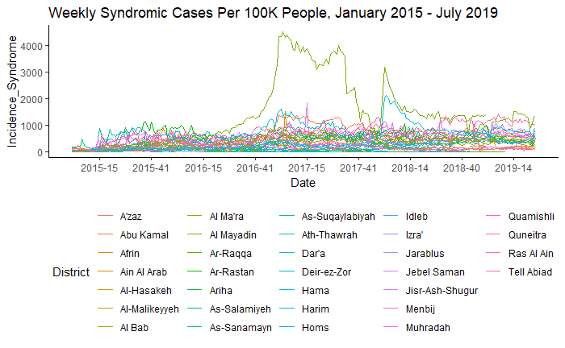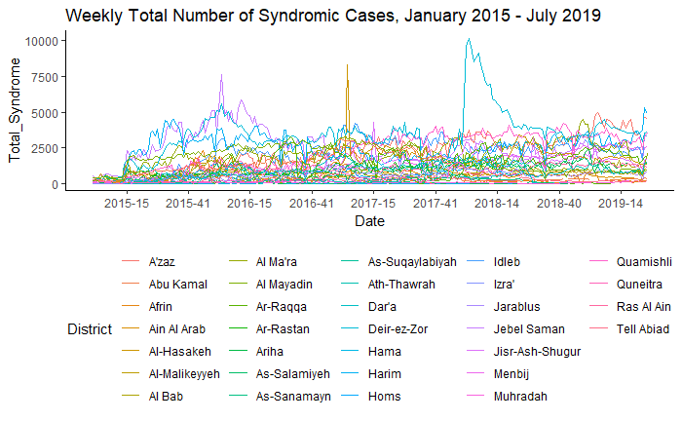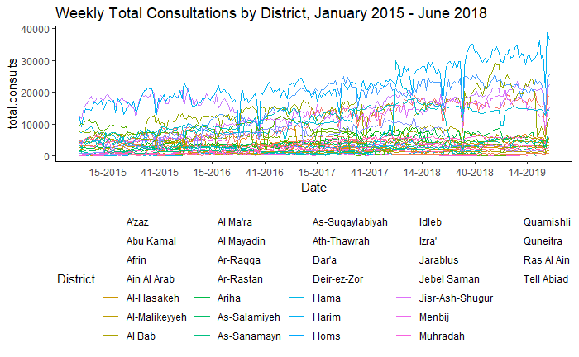

Figure 2

Table 2

Figure 1 shows the total number of syndromic cases captured each week by EWARN between January 1st 2015 and July 31st 2019. Figure 2 shows the total incidence of all syndromic cases in that same period. Figure 3 shows the total number of consultations that were not part of the syndromic surveillance.

**(Need to get from ACU)**:

* Average timeliness and completeness
* SD of timeliness and completeness
* Range of timeliness and completeness
* Geographic distribution of where data collected
* What areas were gained and lost over time
* Geographic distribution of timeliness and completeness
* Primary health care or also other services, i.e. ER?

VPD trends

* Cumulative attack rate at the end of each year
* Peaks and troughs, range of incidence, seasonality
* Which regions primarily affected, and protected

Vaccine preventable diseases (VPDs) were defined as diseases that have a vaccine available, whether or not vaccinations were routinely administered in the different regions of Syria. Influenza like illnesses (ILI) are grouped separately due to its relatively common occurrence that overshadows other syndromes, the low specificity of ILI clinical symptoms, and incomplete protection offered by influenza vaccinations. Note that STF and AJS fit the criteria for both VPD and WASH and were included in both as a point of reference for the scale of case totals and incidence between the two categorizations.

Figure 4

Figure 5

Figure 4 depicts the trends in weekly cases of VPDs between 2015 – 2018. Similarly, Figure 5 shows the trends in incidence of VPDs.

|  |  |  |  |  |  |  |
| --- | --- | --- | --- | --- | --- | --- |
| Year | *Cases of STF* | *Cases of AJS* | *Cases of MEA* | *Cases of MEN* | *Cases of AFP* | Total VPD Cases |
| 2015 | 80,390 | 37,115 | 2,192 | 3,868 | 325 | **123,890** |
| 2016 | 94,248 | 50,332 | 2,110 | 5,941 | 265 | **152,896** |
| 2017 | 77,832 | 39,112 | 7,664 | 5,370 | 406 | **130,384** |
| 2018 | 29,372 | 25,148 | 15,741 | 2,465 | 159 | **72,885** |
| 2019 | 16,013 | 11,841 | 390 | 2020 | 123 | **30,387** |
| **Total** | **323,429** | **184,620** | **30,241** | **22,636** | **1,406** | **562,332** |

Table 2

Measles

Cases of measles were reported in every governorate except for Homs, which underwent a siege in 2017. However, certain governorates have been impacted more than others, and within governorates there are districts with more cases than others. The governorates Ar-Raqqa ad Deir-ez-Zor had the highest number of cases, followed by Idlib and Aleppo.

The greatest incidence was in Al-Mayadin and Abu Kamal Districts in the 2017 outbreak, and Ar-Raqqa, Al-Mayadin, and Deir-ez-Zor had the highest incidence in the 2018 outbreak.

|  |  |  |  |  |  |
| --- | --- | --- | --- | --- | --- |
| Cases of Measles | <5 Male | <5 Female | >5 Male | >5 Female | Total Cases |
| Aleppo Total: | **1663** | **1512** | **1232** | **1045** | **5452** |
| Afrin | 25 | 48 | 127 | 96 | 296 |
| Ain Al Arab | 26 | 21 | 18 | 9 | 74 |
| Al Bab | 161 | 169 | 187 | 150 | 667 |
| A'zaz | 607 | 527 | 325 | 324 | 1783 |
| Jarablus | 146 | 147 | 89 | 109 | 491 |
| Jebel Saman | 255 | 217 | 169 | 134 | 775 |
| Menbij | 443 | 383 | 317 | 223 | 1366 |
| Al-Hasakeh Total: | **195** | **174** | **128** | **103** | **600** |
| Al-Hasakeh | 23 | 18 | 8 | 10 | 59 |
| Al-Malikeyyeh | 28 | 22 | 21 | 27 | 98 |
| Quamishli | 96 | 85 | 57 | 26 | 264 |
| Ras Al Ain | 48 | 49 | 42 | 40 | 179 |
| Ar-Raqqa Total: | **2226** | **2180** | **1937** | **1682** | **8025** |
| Ar-Raqqa | 1843 | 1820 | 1743 | 1537 | 6943 |
| Ath-Thawrah | 254 | 230 | 101 | 85 | 670 |
| Tell Abiad | 129 | 130 | 93 | 60 | 412 |
| Dar'a Total: | **85** | **114** | **35** | **33** | **267** |
| As-Sanamayn | 3 | 4 | 1 | 0 | 8 |
| Dar'a | 39 | 64 | 19 | 23 | 145 |
| Izra' | 43 | 46 | 15 | 10 | 114 |
| Deir-ez-Zor Total: | **2601** | **2608** | **1760** | **1336** | **8305** |
| Abu Kamal | 751 | 815 | 533 | 354 | 2453 |
| Al Mayadin | 658 | 765 | 446 | 288 | 2157 |
| Deir-ez-Zor | 1192 | 1028 | 781 | 694 | 3695 |
| Hama Total: | **28** | **31** | **21** | **10** | **90** |
| As-Salamiyeh | 8 | 3 | 3 | 2 | 16 |
| As-Suqaylabiyah | 7 | 16 | 14 | 7 | 44 |
| Hama | 9 | 10 | 4 | 1 | 24 |
| Muhradah | 4 | 2 | 0 | 0 | 6 |
| Homs Total: | **0** | **0** | **1** | **0** | **1** |
| Ar-Rastan | 0 | 0 | 1 | 0 | 1 |
| Homs | 0 | 0 | 0 | 0 | 0 |
| Idleb Total: | **1745** | **1478** | **876** | **818** | **4917** |
| Al Ma'ra | 128 | 117 | 66 | 55 | 366 |
| Ariha | 92 | 74 | 24 | 34 | 224 |
| Harim | 757 | 647 | 390 | 379 | 2173 |
| Idleb | 595 | 481 | 324 | 264 | 1664 |
| Jisr-Ash-Shugur | 173 | 159 | 72 | 86 | 490 |
| Quneitra Total: | **5** | **15** | **17** | **13** | **50** |
| Quneitra | 5 | 15 | 17 | 13 | 50 |
| *Grand Total:* | **8548** | **8112** | **6007** | **5040** | **27707** |

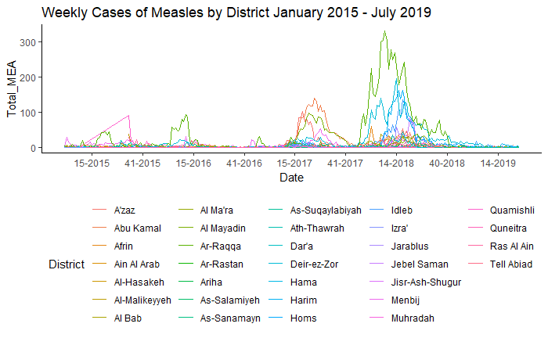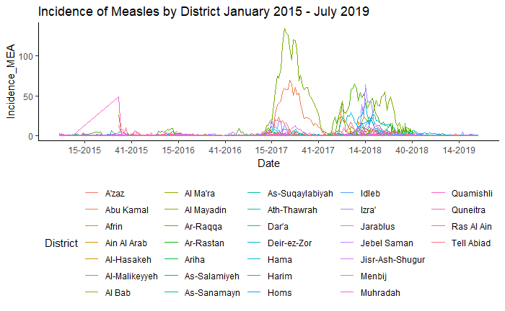

Table 2

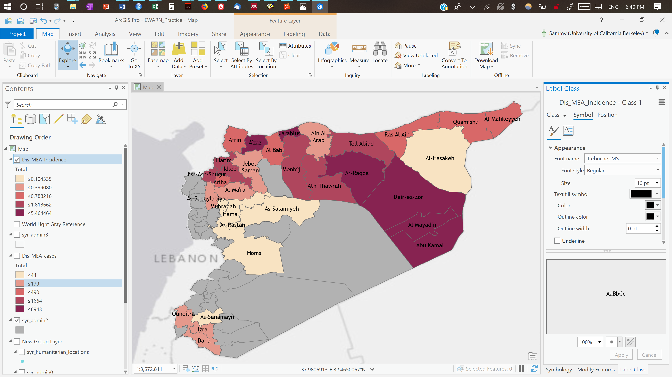

Figure Map of Measles Incidence by Quintile

The outbreaks follow a mostly biannual outbreak trend, with the largest outbreaks of 2017 concentrated in Abu Kamal and Al Mayadin Districts in the Deir-ez-Zor governorate, and while in 2018 the largest outbreaks were concentrated in Al-Mayadin and Deir-ez-Zor districts in Deir-ez-Zor governorate and Ar-Raqqa district of Ar-Raqqa Governorate.

Districts with high incidence of measles in 2017 experienced a reduction in incidence the following year, suggesting a reduction in the at-risk population due to acquired immunity. The surveillance data also reveal a clear springtime peak in incidence, although 2018 experienced a longer period of high-incidence than 2017. The seasonality of measles is typically lost as elimination of measles in a given population is approached, which may provide an important epidemiologic marker to monitor for as vaccination efforts are continued.

* WASH trends

WASH syndromes all had seasonal trends. STF and ABD had spikes in incidence during the mid to late summer weeks, while AJS had mild elevations in incidence during the spring and LEISH experienced large outbreaks in the winter.

Suspected Typhoid Fever

Typhoid fever incidence is typically classified as low (<10 per 100K), medium (10-100 per 100K), high (100-500 per 100K), and very high (>500 per 100K). Incidence in the coverage areas remained within the medium range throughout most of 2015-2018, except for periods of low incidence during the winters. STF cases seem to follow a seasonal trend of annual summer outbreaks. The total number of cases peaked in 2016, as shown in Table 2. Outbreaks seemed to be distributed over a longer period of time, as is seen in Figure 4, which shows broader peaks of suspected typhoid fever epidemics.

Diarrheal Diseases

Diarrheal diseases have dramatically increased over the course of the war, with yearly peaks in the late summer weeks, reaching as high as 216 cases per 100,00 people. 57.55% of cases were in children under the age of 5. There was an even distribution of cases between males and females under the age of five, with 51.63% and 48.37% of cases, respectively. Notably, diarrheal diseases have experienced a surge over the time period, especially in 2017, while the other WASH diseases have remained within a consistent seasonal range.

Leishmaniasis

Leishmaniasis is an example of a syndrome that remained stable over the period of surveillance, with consistent cycles of winter outbreaks. The winter of 2017 had the lowest incidence of reported cases of all the winters captured in this range, as opposed to diarrheal diseases which saw peak incidence in the summer of 2017.

1. Discussion
   * Geographic and demographic distribution
   * What we’ve learned about the transmission patterns and seasonality of diseases
   * Areas hardest hit
   * Where we can focus future research and data collection
   * Limitations (of the data, of the results)
     + What is or could have interfered with results that you were unable to control for
     + Ismail et al. highlighted the advantages and disadvantages of early warning systems succinctly: “Early warning systems have significant advantages in timeliness of reporting, flexibility to incorporate new syndromes of concern, and low administrative and laboratory burden. However, there are equally well-recognized limitations, including low specificity and positive predictive value (especially for diseases with non-specific symptom profiles) and high false-alarm rates, which contribute to difficulties identifying true departures from statistical norms for outbreak detection purposes.”10
     + Dynamic coverage areas: Since EWARN operates in areas outside of Syrian government control, its coverage area has changed over the course of the war, reaching its greatest extent in 2015 before shrinking as government forces advanced.
     + The degree of conflict varied widely over time and by district. Some cities bore a great degree of direct conflict, such as Homs, which was besieged for extended periods of time, or Eastern Aleppo, which experienced wide-spread destruction prior to its capture by government forces. Such periods of intense conflict necessarily influence not only health outcomes, but data collection as well, which limits our ability derive conclusions about the relationship between conflict and infectious diseases. And since the accessibility and security of districts is not uniformly distributed, biases exist in which districts have more reliable data. This is a critical yet unavoidable limitation in the context of war.
     + There is no reliable baseline for which we can compare our data to, with limited publicly accessible information on infectious disease epidemiology prior to the conflict. It is also difficult to compare between ACU’s EWARN and the Syrian MOH’s EWARS because of systematic differences between each.
     + EWARN surveillance was sensitive enough for early detection of outbreaks, such as measles and polio outbreaks, which led to earlier coordinated response from the health cluster.
   * Public health implications
   * Future research
     + What needs to be studied
     + How data could be better collected/needs to be collected
   * Format:
     + Why this is new/important
     + Flush out implications
     + Limitations
     + Challenges ahead, next steps: policy stuff
       - Policy
       - Programmatic changes

Attacks on healthcare (red lines are recorded attacks from PHR)

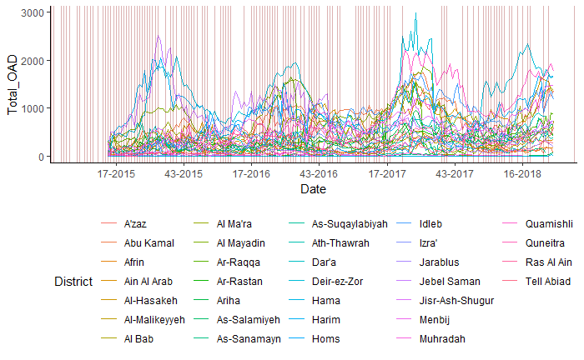

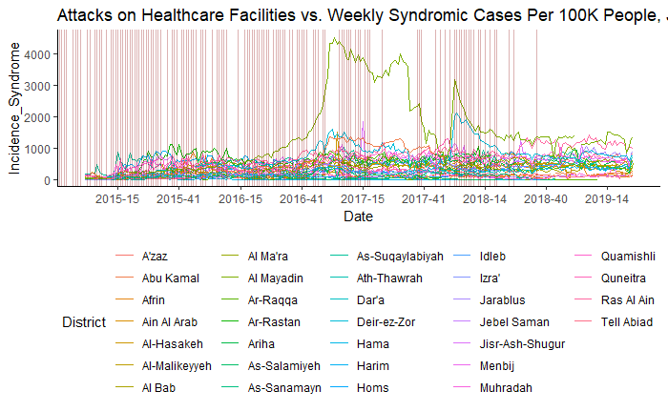

Notes for self:

* Characteristics of the study population in each grouping
  + - Age, sex, regional distribution (SD, mean, range)
    - Maps, Table 1

Potential stat analysis:

* + -separate by region, ones with outbreaks
  + -ANOVA on the incidence rates
    - Attacks as the explanatory, disease as the variable. Need before and after attack data.
  + Measles in region before/after attack: paired T-test (incidence is continuous), need to categorize incidence for X2
  + Measles in two different regions with different attacks: regions are independent (two tests)

Notes:

* + Analysis
    - Poisson
    - Compare stat test (X2 or Pearsons, or ANOVA?) for same region between different years, compare A to B, C, D, and then separate.
      * + https://fhssrsc.byu.edu/SitePages/ANOVA,%20t-tests,%20Regression,%20and%20Chi%20Square.aspx
      * Variables: Year, geographic region, (age?, sex?)
        + Sex: beware of implications. Health seeking behavior, access.
      * Questions
        + Are diseases associated with high conflict?
        + What is associated with better/worse outcomes?
        + What is infrastructure loss associated with?
        + Compare cities that population went up or down?
        + Did populations go down for real or because of the way it was measured?

Ask UNOCHA and ACU

* + - Compare stat test for different regions, table of comparisons
      * Overall
      * By time
    - Vaccination rates: can we get that info?
      * Related to conflict or lack of vaccination?
      * Before conflict and after conflict
    - Failing to reject the null hypothesis does not mean it’s true
      * We have ecologic data, not individual level
    - Interrupted time series:
      * Heavy conflict compared to no conflict
    - Pick pairs to compare diseases to each other.

Yemen data project

Attacks on Healthcare:

From Sayaka:

Methods

Several open source databases were identified to extract data on attacks on healthcare facilities. For the study, the data extracted included: (a) Start Date of Attack, (b) End Date of Attack, (c) Governorate Region of Attack, (d) Weaponry Used, (e) Perpetrator of Attack. Databases maintaining these statistics were identified through a broad, web-based search and were chosen based on the following inclusion criteria: (1) availability of data from the start of the civil war on March 2011, (2) monthly aggregated data, (3) a published and transparent methodology, and (4) a multi-tier verification procedure.

Results

After a broad, web-based search of open-source databases, Physicians for Human Rights' (PHR) “Map of Attacks on Health-Care Facilities in Syria” was chosen as the sole database to source information for attacks on Syrian healthcare facilities. PHR provides the most comprehensive, opensource dataset of attacks on healthcare facilities as the only organization that documented attacks from March 2011. Their methodology is also published and requires a multi-tier verification with at least two independent sources before publication of confirmed attacks online. PHR uses social media, publications and field sources to identify attacks before publishing attacks on healthcare facilities and personnel on their online platform. PHR's database is widely acknowledged in the literature as the most accurate, open source database of attacks on healthcare facilities in Syria.

